

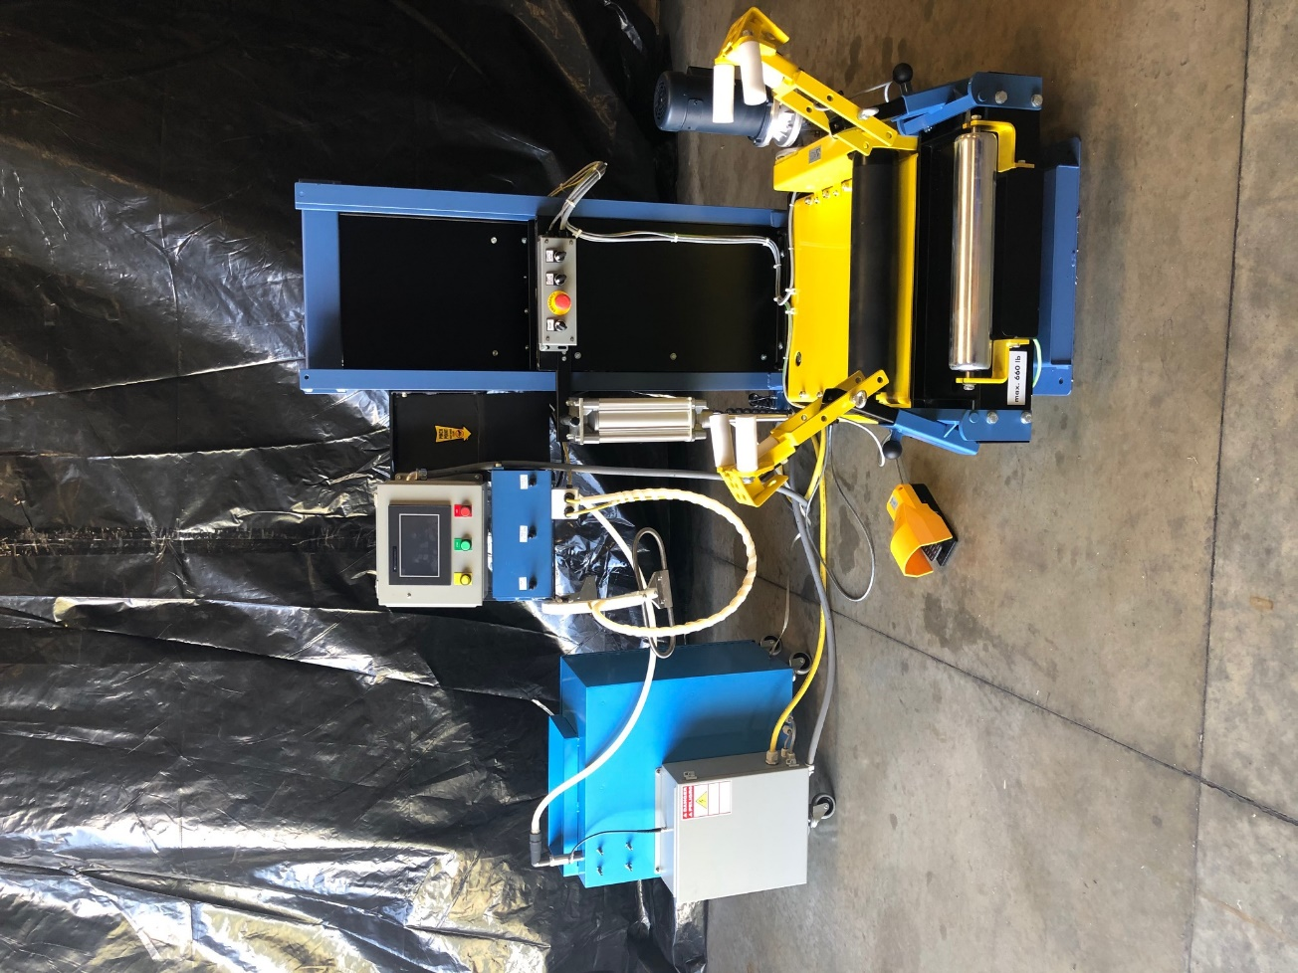

SPECTRA SMART VERSION

MACHINE  TYPE | SPECTRA SMART VERSION
YEAR OF  MANUFACTURE | 2020
SERIAL
NUMBER
MANUFACTURE | CENTRAL MARKETING INC  5001 PUDDLEDOCK ROAD  PRINCE GEORGE, VA 23875  804.733.4684
REV

- INTRODUCTION
  - GENERAL SAFETY
  - LIMITED LIABILITY
  - DEFINITIONS
  - WARRANTY
  - PERSONNEL SELECTION AND REQUIREMENTS
- MACHINE INFORMATION
  - GENERAL DESCRIPTION
  - INTENDED USE
  - PROHIBITED USE
- TECHNICAL DATA
  - TIRE SIZES
  - WEIGHT AND DIMENSIONS
  - COMPRESSED AIR SUPPLY
  - ELECTRICAL SUPPLY
  - SPREADER CAPACITY
- WARNINGS
- MACHINE USE
  - PNEUMATIC CONTROLS
    - SPREADER OPERATING INTERFACE
  - ELECTRICAL CONTROLS
    - SPREADER CONTROL BOX
    - MOTOR CONTROL BOX
    - SPECTRA OPERATOR INTERFACE
    - SPECTRA CONTROL BOX
    - SPECTRA HIGH VOLTAGE BOX
  - RUNNING A TEST
    - LOADING A TIRE
    - AUTOMATIC CYCLE
    - MANUAL OPERATION
    - TIRE UNLOADING
    - ALARM DESCRIPTION
- SETTINGS
  - AUTOMATIC CYCLE TIME ADJUSTMENT
  - SETTING THE DETECTION SENSITIVITY
  - ROTATION SPEED ADJUSTMENT
- MAINTENANCE
  - MAINTENANCE SAFETY
  - ELECTRICAL MAINTENENCE SAFETY
  - MAINTENECE OPERATION
    - DAILY
    - MONTHLY
  - REPLACEMENT PARTS
- INTRODUCTION
  - GENERAL SAFETY
This manual provides the user with the instructions needed to ensure safe and correct use of the machine and to perform maintenance of the machine. All personnel involved in the transportation, installation, commissioning, operation, maintenance and repair of the machine and its accessories must have read and properly understood:
- The operating instructions
- The safety warnings and rules
- The warnings contained in the individual chapters and paragraphs.
It is forbidden for two or more persons to use the machine simultaneously, whether for operating or to carry out maintenance or repairs. The operator must be properly trained to use the machine, to evaluate the characteristics and condition of the tires to be inspected and to perform, when necessary, the adjustments and settings as dictated by the type of job to be done. Persons under the influence of drugs, alcohol or medicines that impair the speed of their reflex reactions must not be allowed to engage in the installation, operation, maintenance or repair of the machine.
Failure to observe the warnings contained in this manual might cause personal injury and even death. The manual must be accompanied by the company’s specific rules, including supervisory and reporting duties, regarding work organization, work cycles, personnel appointed to the various tasks and other matters.
The user must check that the personnel perform their tasks with the full knowledge and awareness of the safety rules and hazards, and that they follow the instructions contained in this manual. The user must also make sure that the machine is always in perfect working order.
The machine may only be used in perfect working order and it must be used by a single trained operative, in compliance with the prevailing safety and accident- prevention regulations. The provision includes observance of the operating and maintenance instructions contained in this manual.
Warnings and danger signs in the form of plates, stickers and marks fitted to the machine must be scrupulously observed. These plates, stickers and marks must not be removed and must be legible at all times.
Do not cover any cooling grills on the electrical cabinet or motors.
It is forbidden to disconnect or modify the safety devices.
Remove any electrical or pneumatic power connections and discharge any remaining air before carrying out any cleaning, maintenance or repairs are completed.
Supply power to the machine to the specific voltage and air in accordance with the supplied requirements.

  - Limited Liability
The information, data and instructions contained in this manual are current at the time of printing and are based on our most up-to-date technical knowledge.
We shall make good any defects and omissions under warranty obligations undertaken at the time of the order, but shall not satisfy any further claim. Demands for compensation, on whatever legal grounds they are made, shall not be considered.
The manufacture disclaims all liability for malfunctions or inefficiencies caused by:
Improper use, negligence, non-maintenance or incorrect maintenance, incorrect maneuvers, incorrect electrical or pneumatic power supply, omission of required adjustments, tampering or modifications not authorized in writing to mechanical, pneumatic, electrical, electronic parts or software programs.
Furthermore, the manufacturer accepts no responsibility in the event that wire or electrode welding jobs are carried out on any part of the machine or even on other machines connected to the same mains power supply, unless the manufacturer has been contacted in advance and the appropriate precautions agreed and implemented.

  - Definitions
User. Denotes the party(business/firm) which uses and employs the machine and assigns suitably trained personnel to operate it.
Operator. Denotes the person instructed by the user to perform specific operations connected with the use of the machine, including necessary cleaning, checks and visual inspections.
Trained personnel. This term denotes an individual who has received instruction and training both on the tasks assigned to him/her and on any dangers occasioned by improper use. The said individual is also well informed and has demonstrated his or her knowledge regarding the necessary safety devices, protective measures, relevant regulations, health and safety rules and work conditions.
Mechanical maintenance technician. The term denotes an individual who is in charge of mechanical adjustments, maintenance and repair.
Electrical maintenance technician. This tern denotes an individual who is in charge of electrical adjustments, maintenance and repair.
Dangerous area. Any area inside or close to the machine, where the presence of a person implies a risk to the health and safety of that person.
Exposed person. Any person totally or partially inside a dangerous area.
Danger. Any cause of possible health and safety damage.
Risk. The product between the probability that an event could happen and the seriousness of injuries or damages to health and safety it can cause.
Protections. Safety measures that protect operators from dangers that cannot be eliminated or mitigated through design only.
Shelter. A protection that consists of a physical barrier.

  - Warranty
This manual contains all the information, rules and standards to be observed. Therefore, it must be read carefully before starting up the machine.
Central Marketing Inc. may not be held liable for any damage or operating abnormalities resulting from failure to observe the service instructions. The machine’s wear parts are not covered by warranty. Any claims under warranty must be reported immediately, as soon as the defect is identified, and the machine’s serial number must also be specified.
The warranty lapses in the following cases:
- Improper use
- Use of work equipment that is not allowed
- Installation and connection of electrical cables performed incorrectly with regulations
- Use of non-original spare parts or accessories
- Modifications made without the permission of Central Marketing Inc. and in particular, modifications which include electrode or wire welding

  - Personnel Selection and Requirements
With respect to the operation or maintenance to be performed independently, the user may only assign operators who:
- Are over the age of 18
- Have suitable physical and mental abilities
- Have been trained in the use or maintenance of the machine and have demonstrated their competence. The training must include teaching of the necessary theoretical concepts regarding the machine and the characteristics of tires, and must also provide sufficient opportunity for the trainees to carry out practical trials and acquire the ability to identify abnormalities that might threaten work safety
- Can be relied upon to perform competently the operations assigned to them
The user must clearly define the tasks and duties of the personnel with regard to operation, maintenance and repairs.

- Machine Information
  - General Description

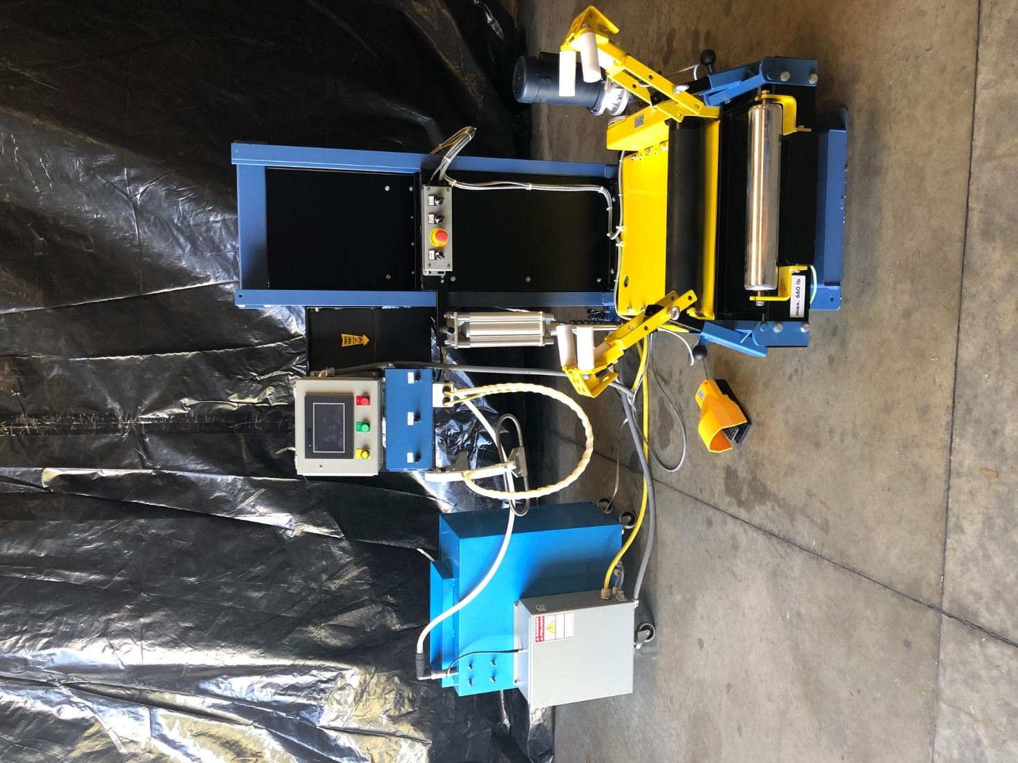
7
8
7
6
5
4
3
2
1

9

11
10

- Spectra Control Box
- Spectra High Voltage Box
- Spectra Operator Interface
- Spreader Operator Interface
- Spreader Control Box
- Foot Pedal
- Spreader Arms
- Tire Carriage
- Motor Control Box
- High voltage probe
- High voltage quick connect block

  - Intended Use
The Spectra tire tester is intended for lifting, rotating and using a high voltage probe to detect nail holes or other flaws that cause a rip, tear, hole or other injury in the lining or tread to the steel belting or through the entire tire in both an automatic or manual operation.
The tire spreader may also be used for visual inspection.

  - Prohibited Use
It is forbidden to use this machine for any purpose other than the ones described in section 2.2. It is also expressly forbidden to use the machine to treat:
- A tire filled with dirt, earth or other substance
- A tire containing water, ice or other liquid
- A tire exceeding the permitted weight limit
- Solid tires
- Tires exhibiting marked mechanical damage (cuts, raised belts, deformed beads, etc.)

- Technical Data
  - Tire Sizes
External Diameter- Max 67”, Bead Diameter- Max 22.5”

  - Weight and Dimensions
Machine Weight: 695lbs
Dimensions of the machine in service: 48”x64”x72.4”

  - Compressed Air Supply
Clean and dry compressed air @ 145 PSI Max
Consumption- 0.7 cu ft/cycle

  - Electrical Supply
120VAC, 8AMP, 50/60HZ

  - Spreader Capacity
Lifting Capacity- Max 660lbs
Spreader Table Roll-on Height- 11”

- Warnings
This equipment operates using high voltage. Read and follow all instructions and warnings in this manual. Failure to do so may result in injury or death.
These operating instructions are intended to explain the correct utilization of the machine and are to be consulted during initial commissioning as well as regularly during the period of use of the machine as well as for accessory parts.
The work stages and safety instructions given do not absolve the user from his general duty of care when using technical machines.
Observe relevant accident prevention.
The machine is only to be operated by persons who have been instructed in the use of the machine and have received training on the machine.
Warning: The voltages inside the electrical cabinets are lethal.
Warning: Disconnect power before opening any electrical cabinets.
Warning: Be sure the electrical connections are properly grounded.
Warning: The electrical cabinets should only be opened by qualified electrical personnel.
Warning: The high voltage electrical cabinet contains high voltage storage capacitors and they must be allowed to discharge for 10 seconds then ground before working in the cabinet.
Do not reach in between moving parts.
Risk of tipping. Anchor the machine securely on a base providing sufficient support.
Every precaution should be taken when moving heavy loads. Only qualified personnel with adequate equipment should move or lift such loads.
Only qualified and properly trained personnel should install and assemble the different components of this machine.
Ensure that you have sufficient air pressure to operate all pneumatic components of this machine.
During the test procedure, this machine will automatically rotate the tire and power the high voltage circuit. Stay away from all moving parts and high voltage discharge points.
Do not wear jewelry or loose clothing during operation.
Do not operate if any part of the equipment is damaged or in need of repair.
Wear suitable protective equipment. Safety Glasses, tight fitting gloves, sturdy shoes).
When not in-use, keep the machine in a dry, well ventilated area.

- Machine Use
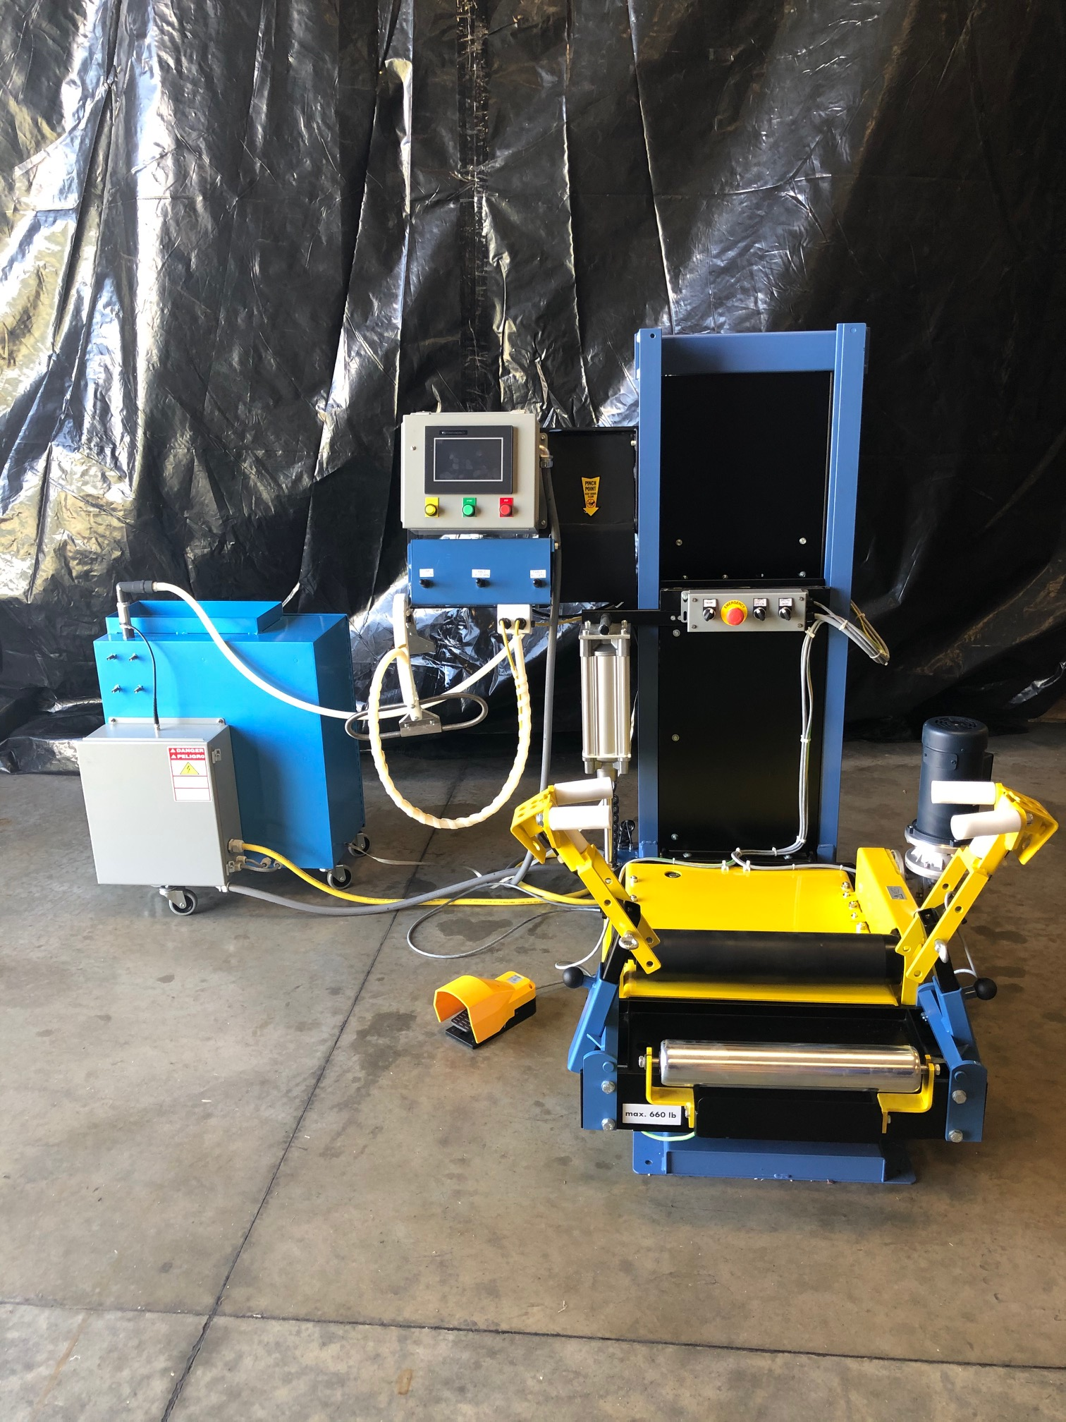
  - Pneumatic Controls
    - Spreader Operator Interface

3
2
1

- Spread arms In/Out
- Table Up/Down
- Table rotate

  - Electrical Controls
    - Spreader Control box
44
3
1
2

- On/Off
- Emergency Stop
- Lights Off/On
- Spectra Enabled/Disabled

    - Motor Control Box
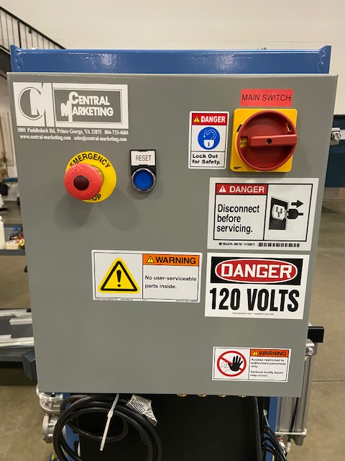

- Emergency Stop
34
2
14
- System Reset
- Electrical disconnect

    - Spectra Operator Interface

- HMi, touch screen
- Manual push button
- Start push button
- Stop push button

    - Spectra Control box

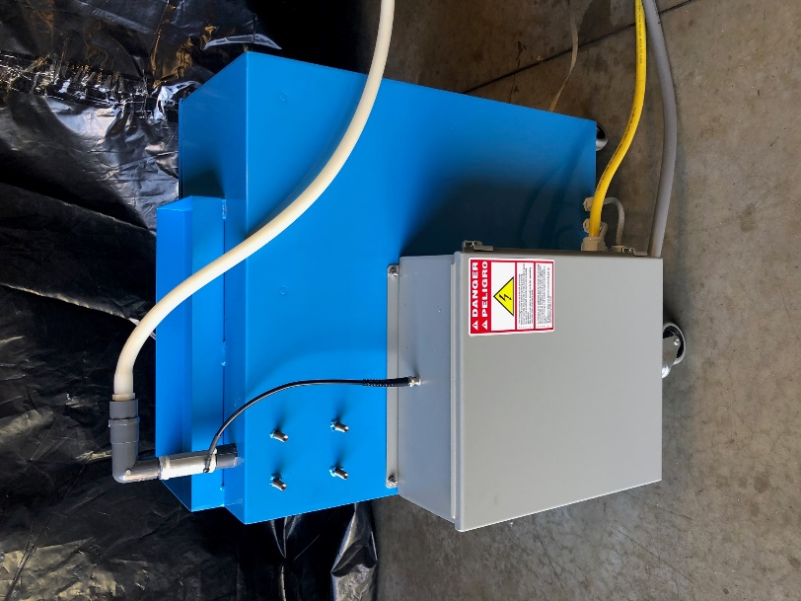
14

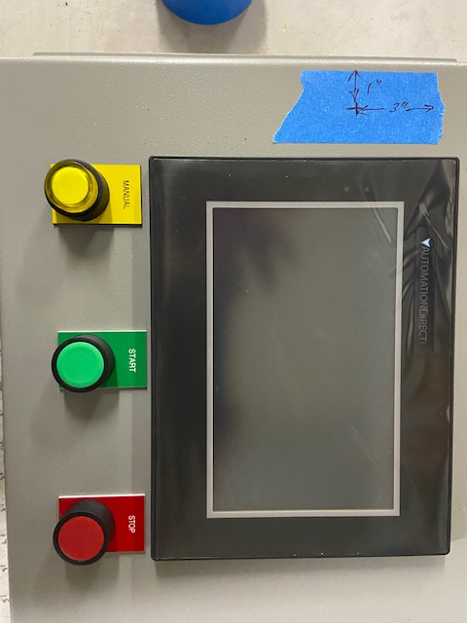
24
4
24
3
14

- BNC/Coax cable
- Output cable to the spreader motor control box

    - Spectra high voltage box
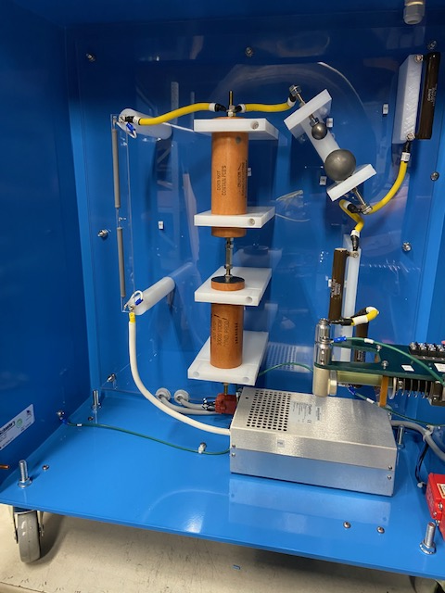

5
3
4
2
14
6
6

7
2

8

9
- 2 meg ohm resistor
- High voltage capacitor
- Small carbon ball
- Large carbon ball
- 150 ohm resistor
- 200 ohm resistor
- High voltage relay
- High voltage power supply
- High voltage disconnect
10
11

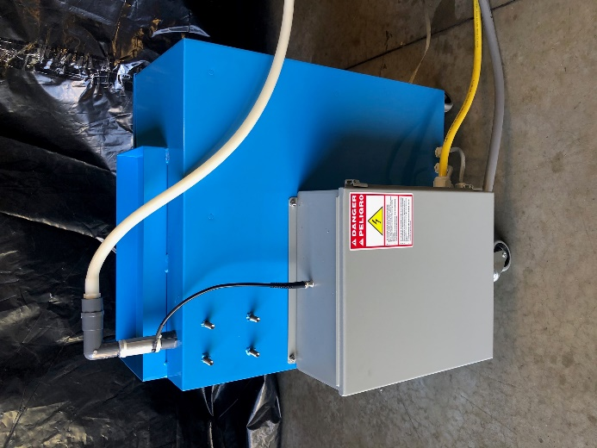
- Flaw detector pick up plate
- High voltage output wire to quick connect block

  - Running a test
Before operating this machine, it is absolutely vital to carefully read and understand the information provided in this manual.
The machine operates in both an Automatic and manual process.
Once a qualified technician has provided compressed air and electrical power to the machine, the machine can be powered on. Confirm all emergency stop buttons are pulled out, then the reset button located on the motor control box can be pressed. This must be done every time power is removed from the machine or the emergency stops are pressed.

    - Loading a tire
Before loading a tire, inspect the tire for debris, liquid, cuts, raised belts, deformed beads, etc.
- Lower the tire carriage to its lowest possible position by means of the “Table Up/Down” pneumatic control.
- Open the spreader arms and adjust the height according to the tire size to be processed.
- Place the tire on the rollers, insert the spreader arms into the tire. You may need to adjust the spread arms by means of the “Spread Arms In/Out” pneumatic control.
- With the spread arms in the tire, spread the tire using the “Spread Arms In/Out” pneumatic control to spread the beads apart. Do no over stress the beads as you can damage the drive motor, tire or other parts of the machine. Just light pressure is needed to keep the tire upright.

    - Automatic cycle
- Insert the high voltage probe into the tire, making sure to position it correctly and the springs of the probe are spread out for maximum coverage of the tire.
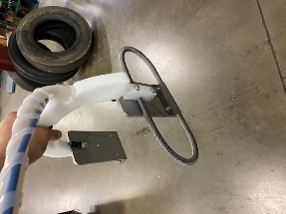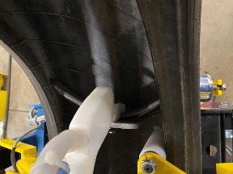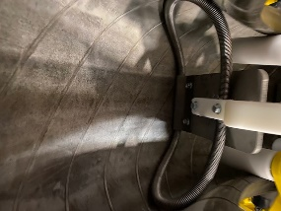
- Confirm that the probe is facing the away from the spreader towards the loading side of the spreader.

- The probe requires that you hold it in place during the testing of the tire throughout the entire test cycle.

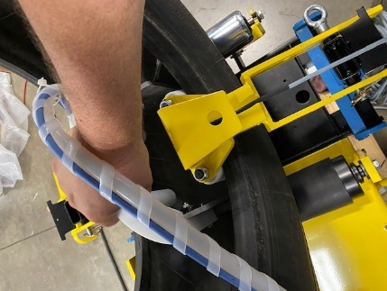
- While holding the high voltage probe against the inner liner of the tire, press the start button on the Spectra operator interface.

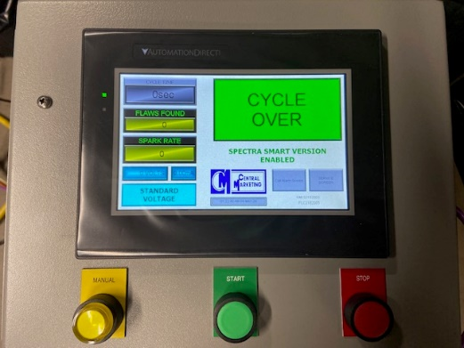
- The motor will start rotating the tire and the high voltage will turn on. These will stay on until either the test cycle completes with no injuries found or a flaw is found.
If no injuries are found and the Cycle Over indicator comes on, you may move to the tire unloading step.

    - Manual Operation
- If an injury or flaw is found, the machine will automatically stop and indicate there is a flaw. The yellow light on the manual push button will aluminate and allow the operator to manually turn on the high voltage by pressing the manual button.

- The high voltage probe can then be moved back and forth in the tire to determine where the flaw is. The operator can then mark the tire according to the company policy to indicate a repair needs to be made.

- The start button can be pressed again when the operator is ready to continue the test. The timer will continue counting down from the spot it left when it found the flaw.
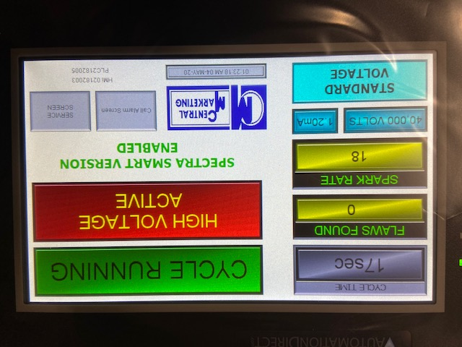
While the test is running, the HMi touch screen will indicate that the high voltage is active, the cycle is running, the number of flaws found in a given test (it will reset the flaw count upon starting a new cycle), the spark rate of the high voltage, the voltage being supplied by the high voltage cabinet, the current consumed by the high voltage power supply and whether you are in standard or boost voltage. During normal operation, standard voltage should be used. Only under direct orders from management should the boost voltage be used. Using the boost voltage when not necessary can cause damage to the tire and cause unneeded stress on the machine components.

    - Tire Unload
- Upon completion of the test cycle, the high voltage probe will need to be removed from the tire and hung back on its hook.
- Lower the tire table down to its lower endstroke using the pneumatic controls “Table Up/Down”.
- Use the spread arm pneumatic control “Arms In/Out” to move the spread arms in.
- Remove the spread arms from the tire.
- Unload the tire from the table.

    - Alarm Descriptions
- Spark rate too low
  - The spark rate is too slow and there is a posability we may miss flaws. This is caused by failed parts in the high voltage cabinet or the carbon balls are too far apart. If this message is displayed on the screen, have a trained technician make the necessary repairs or contact the manufacturer to get technical help.
  - The spark rate is too high. There is a possibility we may miss flaws. This is caused by failed parts in the high voltage cabinet or miss-calibration of the carbon balls. If this message is displayed on the screen, have a trained technician make the necessary repairs or contact the manufacturer to get technical help.
  - The high voltage cabinet door is open. This is caused by the high voltage door being left open after a repair or service. The high voltage cabinet door interlock is not engaged. If this message is displayed on the screen, have a trained technician make the necessary repairs or contact the manufacturer to get technical help.

- Settings
  - Automatic Cycle time adjustment
The cycle time can be adjusted by access the service screen via the HMi touch screen. After the service screen button is pressed, you will be prompted to enter a security code.

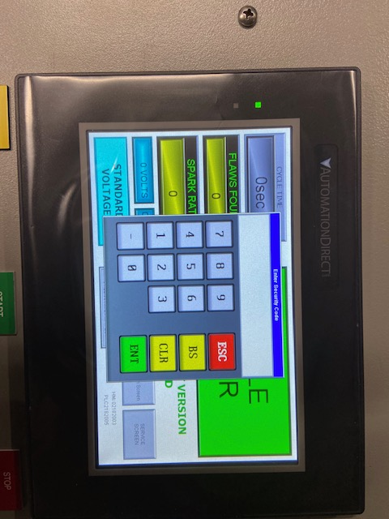
This code will be known to management. Enter the code, then press ENT.
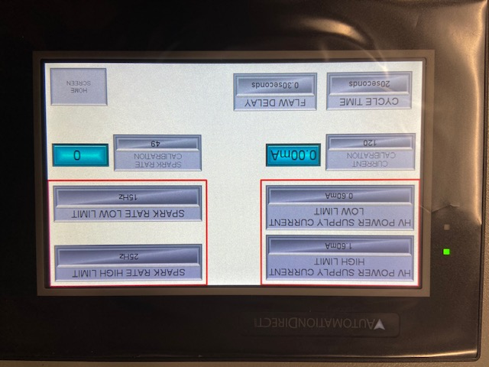
Do not adjust any settings on this screen other than the Cycle time unless specifically instructed to do so by the manufacturer’s technical advisor.
Press the home screen button when done making the adjustments.
6.2. The detector circuit used on the Spectra can be adjusted if false positives are being found, or if injuries or flaws are being missed. Please contact the manufacturer is this is needed and a technician will assist in this operation.
6.3. The rotation speed of the tire can be adjusted slightly to achieve the desired test speed. There is a limit at how fast the tire can spin and the ability to detect flaws or injuries.
The speed pot to make this adjustment is located in the Spectra control box.
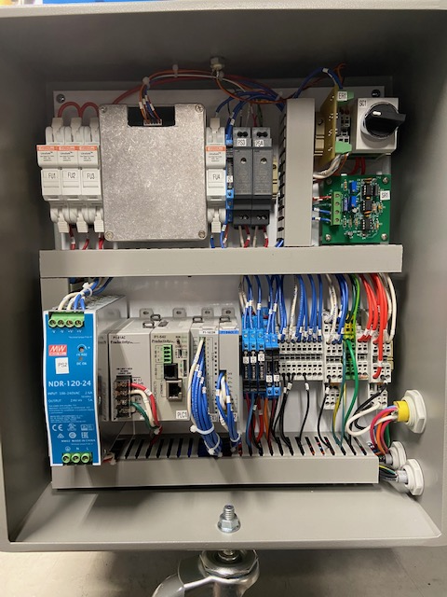
This should only be done by a trained technician and under direct instruction from management.
- Maintenance
  - Maintenance Safety
- Maintenance denotes all servicing, inspection and repair work done to the equipment.
- Mechanical and electrical repairs and adjustments may only be performed by qualified personnel. It is forbidden for unauthorized persons to perform any work on the machine.
- The required adjustments, maintenance work and inspection must be performed at the specific intervals and in compliance with the instructions regarding the replacement of components/subassemblies.
- You must comply with environmental protection regulations with regard to the disposal of waste and parts replaced.
- To prevent personal injury during maintenance, adjustments or repairs, you must only use appropriate and correctly calibrated tools and instruments.
  - Electrical Maintenance Safety
- Work on the electronics and the electrical components may only be carried out by qualified electricians.
- Adhere to any lock out tag out requirements implemented by the facility.
- Use only original fuses with the required amperage. Defective fuses must not be repaired but replaced with fuses of the same kind.
- The electrical equipment and electrical system on board the machine must be inspected and checked at regular intervals. Defects, such as loose connections, damaged power cables and worn protection device contacts, must be repaired immediately.
- Should it be necessary to work on live parts, the electrician must be accompanied by a second person who, in the event of an emergency, should press the emergency stop button.
- Cut off the power supply before disconnecting or connecting up the plug.
  - Maintenance Operation
    - Daily
- The high voltage output wire must be checked for damage, kinks or breaks before every use. Immediately replace if defective.
- Inspection of the high voltage probe should be done before every use. Check high voltage electrical connection to the probe of the high voltage output wire. Immediately replace if defective.
- The high voltage probe bearings should be cleaned of dirt, rubber dust, bead lubricant or any other containment. Immediately replace if defective.
- Check the articulating arms for proper operation. Remove any dirt, rubber dust, bead lubricant or any other containment. Immediately replace if defective.
- The sidewall wires should be inspected for kinks or any defects. Replace before operation of the machine. Failure to do so will result in missed flaws.
- The key chains must be inspected before each use. Replace key chains if missing or defective. Failure to do so will result in missed flaws.
    - Monthly
- Machine components are to be cleaned and dirt and bead lubricant should be removed before every use.
- Piston rod of the pneumatic cylinders is to be regularly cleaned of dirt and bead lubricant in order to prevent damage to the cylinder seals.
- Pneumatic fittings and hoses are to be regularly checked for leaks and kinks.
- Drive chain is to be regularly checked for tightness and grease.
- Guide rails of the elevating device are to be occasionally lubricated with grease.
- Swivel joint of the swivel device and the spread devices occasionally must be lubricated with universal grease.
  - Replacement Parts
When ordering replacement parts, please specify the following:
- The serial number and year of manufacture of your machine
- The part number, if known
- A description of the part needed

